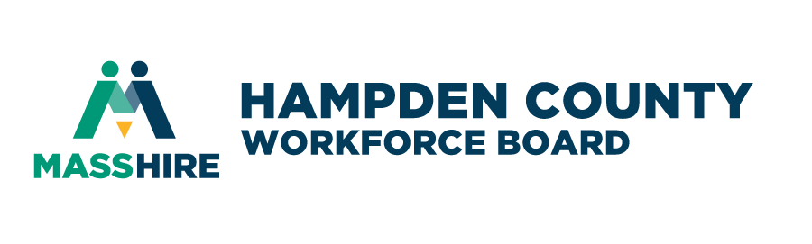
Year-Round Youth Services in Hampden County under the Workforce Innovation and Opportunity Act (WIOA)
Bidder’s Conference Agenda
March 11, 2026, 9:00 a.m.
Zoom Link Info:
Join Zoom Meeting
https://us02web.zoom.us/j/89086303668
Meeting ID: 890 8630 3668
- Purpose of RFP
- Funds Available
- Roles of WDB/Fiscal Agent, One-Stops
- Required Services
- The “14 Elements” & Program Design Considerations
- Submission Timeframe & Review Process
- Budget
- Questions

