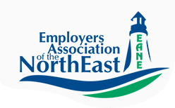

Masshire Hampden County Workforce Board

Electro-Mechanical Technical Skills Needs Survey

October 2019

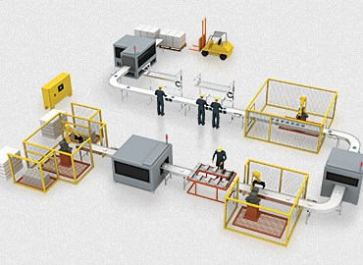

Table of Contents
Introduction 3
Key Findings 4
Next Steps 8
Complete Electro-Mechanical Skills Survey 9

Introduction

This survey is in response to feedback from manufacturers in Western MA and northern CT on the skills gap of new pipeline employees and incumbent workers with electro-mechanical competencies. In addition, concerns were raised on the ability of the local community colleges to address the electro-mechanical skills training requirements based on the capacity of the training programs.
In collaboration with the Employers Association of the North East (EANE) and the Associated Industries of Massachusetts (AIM), a 12 question survey was distributed to regional manufacturers and related service industries to provide a quantitative analysis of present and projected needs for these knowledge and skills. The survey was framed with these topics:
- 12 core skill sets that are common to occupations that require electro-mechanical skills
- Analysis of the employee pipeline required-new worker, incumbent worker or the ability to hire experienced workers
- Is this an existing or projected need or both
- The level of projected hiring
The survey was distributed from June 2019 to October 2019 with a total of 39 employers (37 non-duplicated) across Western MA and Northern CT participating.
Based on survey responses, the results of the survey will be used to:
- Quantify the scale of this labor force need for these specific skills across the Pioneer Valley
- Review the existing regional training programs for capacity to provide an adequate amount of participants to the labor force based on employer demand
- Review if the current curriculums used by vocational schools and community colleges are employer demand driven based on these specific employer occupational requirements
- Review if there is adequate teaching capacity for these skills across the region
- For incumbent employees, determine if the Workforce Training Fund has the adequate trainers available, and that it is being utilized effectively by employers

Key Findings

Question #5 - Does your organization have an existing or projected need for staff with Electro-Mechanical skills and competencies?

- Of the 39 total respondents to the survey, 35% did not have a need for staff with electro-mechanical skills while 65% did have this requirement.
- 43.6% of total employer respondents had 100+ employees.
- Of the 65% of employers with the need for electro-mechanical skills, 62.5% of these companies had 100+ employees which clearly demonstrates the need of the regional large manufacturers in addition to small to medium size enterprises.
- For companies that have a need for these skill sets there is a higher immediate need but the chart also demonstrates the need over the next 2-4 years

Question # 5 - Answer Choices | Responses | Employers
Yes, we have immediate needs | 38.46% | 15
Yes, we have a need in the next year | 20.51% | 8
We project a need in the next 2-4 years | 23.08% | 9
We have no need for staff with theses skill sets | 30.77% | 12
Other (please specify) # | 2.56% | 1
Total Respondents: 39
Other (please specify)
#We have need for mechanical running machinery & set up, not electro-mechanical

Question #6 - If your organization has identified a need for electro-mechanically trained staff, are you looking to:

Question # 6 - Answer Choices |  | Responses | Employers
Hire new staff with the required educational training (entry-level) |  | 56.67% | 17
Hire new staff with the required experience and education |  | 73.33% | 22
Train existing staff at local colleges |  | 36.67% | 11
Other (please specify) # |  | 20.00% | 6
Total Respondents: 30
# | Other (please specify)
1 | Need help in manufacturing will train right person
2 | Open to any of the above options
3 | Build from within
4 | n/a
5 | Combination of the above
6 | Looking for team leaders-that will be working supervisors
This chart demonstrates, at 73.3%, that employers would prefer to hire individuals that have the experience and education for their employment needs. However 56.7 % of respondents are open to hiring entry-level educated trainees. There was a 36.6 % response to training existing staff at local community colleges. Much like the occupational situation with Machinists over the past five years, this presents an opportunity for apprenticeship and internship opportunities.

Question #7 - How many staff members with electro-mechanical skills do you plan to hire?

Number to Hire | 2019 | 2020 | 2021 | 2022 | Total Respondents
1-5 | 57.14%  16 | 57.14%  16 | 39.29%  11 | 39.29%  11 | 28
5-10 | 40.00%  2 | 80.00%  4 | 40.00%  2 | 0.0%  0 | 5
10+ | 0.0%  0 | 0.0%  0 | 100.00%  2 | 50.00%  2 | 2

This chart clearly demonstrates that the majority of employers will be hiring 1-5 staff members over the next four years. A smaller group of employers will be hiring 5-10 employees over the next four years with and even smaller group hiring 10+ employees in 2021 and 2022. It is important to identify these employers for possible collaborative partnerships.

Question# 9 - What positions are you looking to hire individuals with Electro-Mechanical skills?

Question # 9 - Answer Choices |  | Responses | Employers
Electro-Mechanical Technician |  | 44.83% | 13
Robotics Technician |  | 20.69% | 6
Maintenance technicians |  | 62.07% | 18
Machine Repair Technicians |  | 48.28% | 14
Manufacturing Technicians |  | 48.28% | 14
Equipment Assemblers |  | 10.34% | 3
Field Service Technicians |  | 6.90% | 2
Other (please specify) |  | 10.34% | 3
Total Respondents: 29
# | Other (please specify)
1 | Set-up/ Maintenance / Machine Operators
2 | Electrical Engineers
3 | Millrights and rigging technicians with heavy handling equipment skills and background

The top four occupations identified by employers in Question # 9 were:

- Maintenance Technicians 62.7%
- Machine Repair Technicians 48.3%
- Manufacturing Technicians 48.3%
- Electro-Mechanical Technicians 44.8%
This is interesting as, for bullets 1, 2 and 4 this demonstrates a clear need for machine repair, troubleshooting and equipment installation. In addition, the occupational titles of maintenance technician and machine repair technician may actually be the same position in many organizations based on the specific skills and competencies required. With the manufacturing technician, employers may be interested in broadening the skill sets of staff that may be set-up technicians or operators. The selection of these four occupations provides an opportunity to define two career pathways utilizing and, in some cases, updating curriculum topics.

Question #10 - Please rank the following Electro-Mechanical skill sets in the order of importance to your organization.

 | Not Required | Lowest Priority | Medium Priority | High Priority | Total Respondents
Pneumatics/Hydraulics | 21.43%  6 | 21.43%  6 | 42.86%  12 | 14.29%  4 | 28
Electrical/Electronics | 10.34%  3 | 3.45%  1 | 48.28%  14 | 41.38%  12 | 29
Motor Control Systems | 15.38%  4 | 11.54%  3 | 38.46%  10 | 38.46%  10 | 26
Programmable Logic Controllers | 14.29%  4 | 10.71%  3 | 42.86%  12 | 35.71%  10 | 28
Optical Sensors & Networks | 14.29%  4 | 32.14%  9 | 46.43%  13 | 7.14%  2 | 28
Problem Diagnosis & Troubleshooting | 3.45%  1 | 6.90%  2 | 27.59%  8 | 62.07%  18 | 29
Microsoft Applications | 28.57%  8 | 35.71%  10 | 28.57%  8 | 10.71%  3 | 28
Preventative Maintenance | 7.14%  2 | 14.29%  4 | 28.57%  8 | 53.57%  15 | 28
Hoisting and Forklift License | 29.63%  8 | 40.74%  11 | 18.52%  5 | 11.11%  3 | 27
Basic Engine Lathe and Bridgeport Machining | 37.04%  10 | 22.22%  6 | 18.52%  5 | 22.22%  6 | 27
Advanced Machining (CNC) | 37.04%  10 | 22.22%  6 | 14.81%  4 | 25.93%  7 | 27
Blueprint Reading | 17.86%  5 | 21.43%  6 | 17.86%  5 | 46.43%  13 | 28

The emphasis for this question was the skills that were identified as medium and high priority for foundational training topics. As an initial measure of the responses, the observations were limited to response rates of 40% or higher.
- Problem Diagnosis and Troubleshooting 62% High Priority
- Preventive Maintenance 53.6% High Priority
- Blueprint Reading 46.4% High Priority
- Electrical/Electronics 41.4% High Priority (48.3% medium)
- Optical Sensors and Networks 46.4% Medium Priority
- Programmable Logic Controllers 42.9% Medium Priority
- Pneumatics/Hydraulics 42.9% Medium Priority
These selections were not a surprise based on the responses in Question # 9. In addition, within the Low Priority category with a 40.74% response, was the need for the Hoisting and Forklift license.

Question #11 - What schools or training organizations do you work with to train your employees for Electro-Mechanical skills?

ANSWER CHOICES | RESPONSES
Springfield Technical Community College | 36.67% | 11
Asnuntuck Community College | 16.67% | 5
Berkshire Community College | 6.67% | 2
Greenfield Community College | 10.00% | 3
Local or regional Vocational Technical High School | 30.00% | 9
Third-Party/Private Training Provider (vendor) | 23.33% | 7
Third-Party/Private Training Provider (Workforce Training Fund Trainer) | 13.33% | 4
Internal training program or On-the-Job Training | 60.00% | 18
Total Respondents: 30

With a 60% response rate, the majority of respondents have indicated the majority of training happens through On-The-Job (OJT) or through a company internal training program utilizing subject matter experts or OEM vendors. More information is required to determine how the community colleges and vocational schools are being utilized for incumbent worker training.

Next Steps

- A small employer group of survey respondents will be convened in January 2020 to discuss the results of the survey to get a more detailed view of the challenges they are having meeting these occupational requirements. The results will also be present with a broader audience of manufactures, many of whom did not participate in the survey, in February 2020 to get additional information relating to survey analysis.
- The results of the two employer group meetings will determine the analysis approach to the electro-mechanical training structure that is present available to employers such as:
  - Training program duration
  - Course alignment with employer requirements
  - Course rigor and relevance
  - Training and Vendor availability
  - Incumbent versus new pipeline training
  - Instructor and program capacity
  - Training facility and equipment
  - Funding opportunities

Complete Electro-Mechanical Skills Survey
Q1 - What is the name of your business?
 | Answered: 39 | Skipped: 0
# | RESPONSES | DATE
1 | Berkshire Corporation | 9/18/2019 5:25 PM
2 | Sanderson MacLeod, Inc. | 9/17/2019 12:40 PM
3 | Industrial Steel & Boiler Services, Inc. | 9/17/2019 6:42 AM
4 | Quabbin Wire & Cable Co., Inc. | 9/13/2019 12:37 PM
5 | Governors America Corporation | 9/12/2019 2:59 PM
6 | Industrial Etching, Inc | 9/11/2019 4:47 PM
7 | Berkshire Sterile Manufacturing | 9/11/2019 3:58 PM
8 | Berry Global, Inc. | 9/11/2019 3:26 PM
9 | Vaupell Northeast Molding | 9/11/2019 2:18 PM
10 | Covestro | 9/11/2019 2:06 PM
11 | Pilot Precision | 9/11/2019 1:51 PM
12 | Smithfield/Carando Foods | 9/11/2019 1:50 PM
13 | Dielectrics, Inc | 9/11/2019 1:23 PM
14 | Cartamundi | 9/11/2019 1:18 PM
15 | Electro-Term, Inc. | 9/11/2019 1:06 PM
16 | Kanzaki Specialty Papers Inc. | 9/11/2019 12:57 PM
17 | OMG Inc | 9/11/2019 12:57 PM
18 | EXCEL DRYER INC | 9/11/2019 12:34 PM
19 | Westside Finishing Company, Inc. | 9/6/2019 12:42 PM
20 | Convergent - Photonics, LLC | 9/5/2019 9:31 AM
21 | Charter NEX | 9/4/2019 7:23 AM
22 | Genevieve Swiss Industries, Inc. | 8/30/2019 9:52 AM
23 | Neenah, Inc. | 8/29/2019 9:48 AM
24 | Peerless Precision, Inc. | 8/29/2019 8:37 AM
25 | Bete Fog Nozzle, Inc. | 8/29/2019 7:56 AM
26 | Pilot Precision Products | 8/28/2019 6:56 PM
27 | Barnhardt Manufacturing Company | 8/28/2019 6:55 PM
28 | Eastern Etching | 8/28/2019 3:47 PM
29 | SWM | 8/28/2019 3:43 PM
30 | Lenco Industries Inc. | 8/28/2019 3:40 PM
31 | LLumin | 7/18/2019 11:24 AM
32 | Callaway Golf | 7/17/2019 1:07 PM
33 | EIS WIRE AND CABLE | 7/15/2019 11:47 AM
34 | Pelican Products | 7/15/2019 10:59 AM
35 | Eppendorf Manufacturing | 6/17/2019 3:13 PM
36 | Smith & Wesson | 6/14/2019 1:30 PM
37 | Peerless Precision, Inc. | 6/12/2019 3:54 PM
38 | Savage Arms Inc. | 6/12/2019 3:27 PM
39 | Chicopee Industrial Contractors, Inc | 6/12/2019 2:16 PM

Q2 - Which county is your organization located?
Hampden
Hampshire
Franklin
Answered: 35 Skipped: 4
Berkshire
Other (please specify)

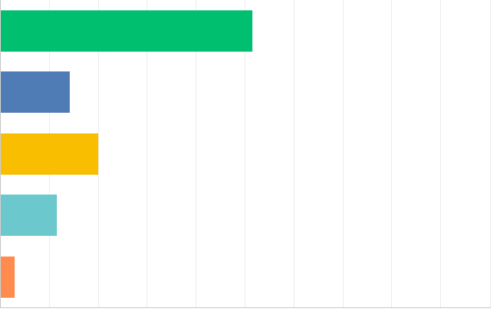

0% 10% 20% 30% 40% 50% 60% 70% 80% 90% 100%
ANSWER CHOICES | RESPONSES
Hampden | 51.43% | 18
Hampshire | 14.29% | 5
Franklin | 20.00% | 7
Berkshire | 11.43% | 4
Other (please specify) | 2.86% | 1
TOTAL |  | 35

# | OTHER (PLEASE SPECIFY) | DATE

1 Hartford County in CT 6/17/2019 3:13 PM

Q3 - What city are you located in?
 | Answered: 38 | Skipped: 1
# | RESPONSES | DATE
1 | Palmer | 9/17/2019 12:40 PM
2 | Chicopee | 9/17/2019 6:42 AM
3 | Ware | 9/13/2019 12:37 PM
4 | Agawam | 9/12/2019 2:59 PM
5 | E Longmeadow | 9/11/2019 4:47 PM
6 | Lee | 9/11/2019 3:58 PM
7 | Easthampton | 9/11/2019 3:26 PM
8 | Agawam | 9/11/2019 2:18 PM
9 | South Deerfield | 9/11/2019 2:06 PM
10 | Deerfield | 9/11/2019 1:51 PM
11 | Springfield | 9/11/2019 1:50 PM
12 | Chicopee | 9/11/2019 1:23 PM
13 | East Longmeadow | 9/11/2019 1:18 PM
14 | Springfield | 9/11/2019 1:06 PM
15 | Ware | 9/11/2019 12:57 PM
16 | Agawam | 9/11/2019 12:57 PM
17 | EAST LONGMEADOW | 9/11/2019 12:34 PM
18 | Holyoke | 9/6/2019 12:42 PM
19 | Chicopee | 9/5/2019 9:31 AM
20 | Turners Falls | 9/4/2019 7:23 AM
21 | Westfield | 8/30/2019 9:52 AM
22 | Pittsfield and Housatonic | 8/29/2019 9:48 AM
23 | Westfield | 8/29/2019 8:37 AM
24 | Greenfield | 8/29/2019 7:56 AM
25 | South Deerfield | 8/28/2019 6:56 PM
26 | Colrain | 8/28/2019 6:55 PM
27 | Chicopee | 8/28/2019 3:47 PM
28 | Greenfield | 8/28/2019 3:43 PM
29 | Pittsfield | 8/28/2019 3:40 PM
30 | West Springfield | 7/18/2019 11:24 AM
31 | Chicopee | 7/17/2019 1:07 PM
32 | South Hadley | 7/15/2019 11:47 AM
33 | South Deerfield | 7/15/2019 10:59 AM
34 | Enfield CT | 6/17/2019 3:13 PM
35 | Springfield | 6/14/2019 1:30 PM
36 | Westfield | 6/12/2019 3:54 PM
37 | Westfield | 6/12/2019 3:27 PM
38 | Chicopee | 6/12/2019 2:16 PM

Q4 - How many total employees do you have?
Answered: 39 Skipped: 0

Greater than 100
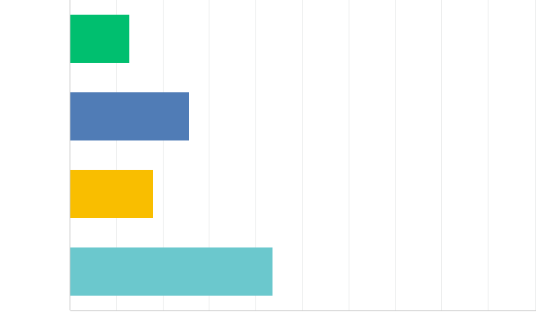
1-25
26-50
51-100

0% 10% 20% 30% 40% 50% 60% 70% 80% 90% 100%
ANSWER CHOICES | RESPONSES
1-25 | 12.82% | 5
26-50 | 25.64% | 10
51-100 | 17.95% | 7
Greater than 100 | 43.59% | 17
TOTAL |  | 39

Q5 Does your organization have an existing or projected needs for staff
with Electro-Mechanical skills and competencies?
Answered: 39 Skipped: 0

Yes, we have immediate needs
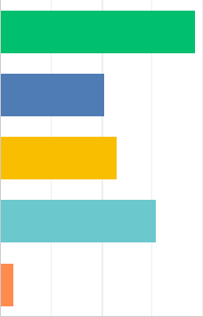
Yes, we have a need in the next year
We project a need in the next 2-4 years
We have no need
Other (please
specify)

0% 10% 20% 30% 40% 50% 60% 70% 80% 90% 100%
ANSWER CHOICES | RESPONSES
Yes, we have immediate needs | 38.46% | 15
Yes, we have a need in the next year | 20.51% | 8
We project a need in the next 2-4 years | 23.08% | 9
We have no need for staff with these skill sets | 30.77% | 12
Other (please specify) | 2.56% | 1
Total Respondents: 39

# | OTHER (PLEASE SPECIFY) | DATE

1 We have need for mechanical running machinery & set up not electro-mechanical 9/11/2019 4:47 PM

Q6 - If your organization has identified a need for electro-mechanically
trained staff, are you looking to:
Answered: 30 Skipped: 9
Hire new staff with the required educational training
Other (please specify)
Hire new staff with the required experience and education
Train existing staff at loc.al colleges.

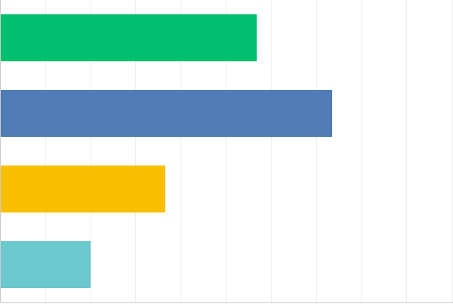

0% 10% 20% 30% 40% 50% 60% 70% 80% 90% 100%
ANSWER CHOICES | RESPONSES
Hire new staff with the required educational training (entry-level) | 56.67% | 17
Hire new staff with the required experience and education | 73.33% | 22
Train existing staff at local colleges | 36.67% | 11
Other (please specify) | 20.00% | 6
Total Respondents: 30
# OTHER (PLEASE SPECIFY) | DATE
1 need help in manufacturing will train right person | 9/11/2019 4:47 PM
2 Open to any of the above options | 9/11/2019 1:50 PM
3 build from within | 9/11/2019 1:23 PM
4 n/a | 8/28/2019 3:43 PM
5 Combination of the above | 7/15/2019 10:59 AM
6 Looking for team leaders - that will be working supervisors | 6/12/2019 2:16 PM

Q7 - How many staff members with electro-mechanical skills do you plan to hire?
Answered: 28 Skipped: 11

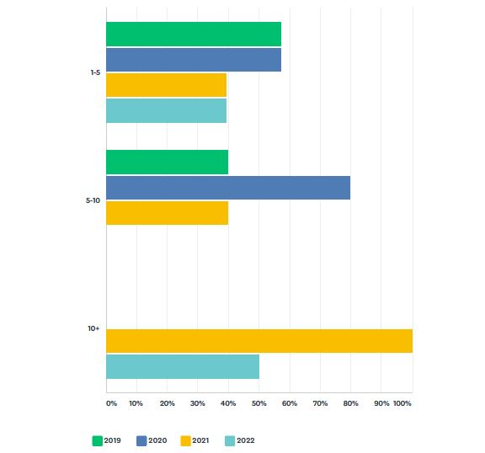

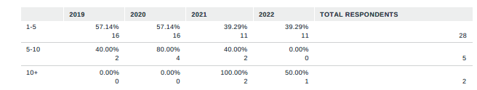

Q8 - Would these be permanent or temporary employees?
Permanent
Temporary
Temp to Hire
Answered: 29 Skipped: 10
0% 10% 20% 30% 40% 50% 60% 70% 80% 90% 100%
ANSWER CHOICES | RESPONSES
Permanent | 96.55% | 28
Temporary | 0.00% | 0
Temp to Hire | 10.34% | 3
Total Respondents: 29

Q9 - What positions are you looking to hire individuals with Electro-
Mechanical skills?
Answered: 29 Skipped: 10
Electro-Mechanical Technician
Robotics Technicians
Maintenance Technicians
Machine Repair Technicians
Manufacturing Technicians
Equipment Assemblers
Field Service Technicians
Other (please
specify)

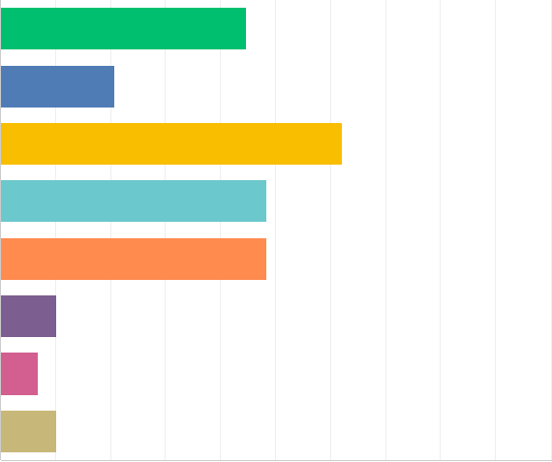

0% 10% 20% 30% 40% 50% 60% 70% 80% 90% 100%
ANSWER CHOICES | RESPONSES
Electro-Mechanical Technician | 44.83% | 13
Robotics Technicians | 20.69% | 6
Maintenance Technicians | 62.07% | 18
Machine Repair Technicians | 48.28% | 14
Manufacturing Technicians | 48.28% | 14
Equipment Assemblers | 10.34% | 3
Field Service Technicians | 6.90% | 2
Other (please specify) | 10.34% | 3
Total Respondents: 29

# | OTHER (PLEASE SPECIFY) | DATE
1 | Set-Up / Maintenance / Machine Operators | 9/17/2019 12:40 PM
2 | Electrical Engineers | 8/28/2019 3:40 PM
3 | Millwrights and rigging technicians with heavy handling equipment skills and background | 6/12/2019 2:16 PM

Q10 - Please rank the following Electro-Mechanical skill sets in the order of
importance to your organization
Answered: 29 Skipped: 10
Pneumatics / Hydraulics

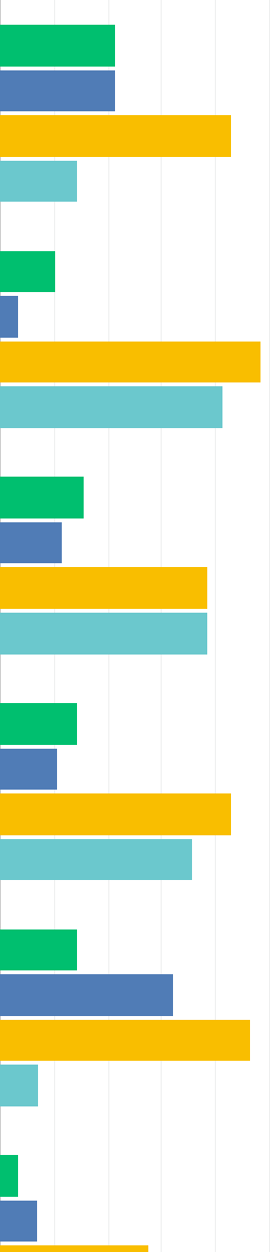
Optical Sensors and. Networks
Programmable Logic Controllers
Electrical / Electronics
Motor Control Systems
Problem Diagnosis and Troubleshooting

Microsoft Applications
Preventative Maintenance
Hoisting and Forklift...
Basic engine lathe and...
Advanced Machining (CNC)
Blueprint Reading
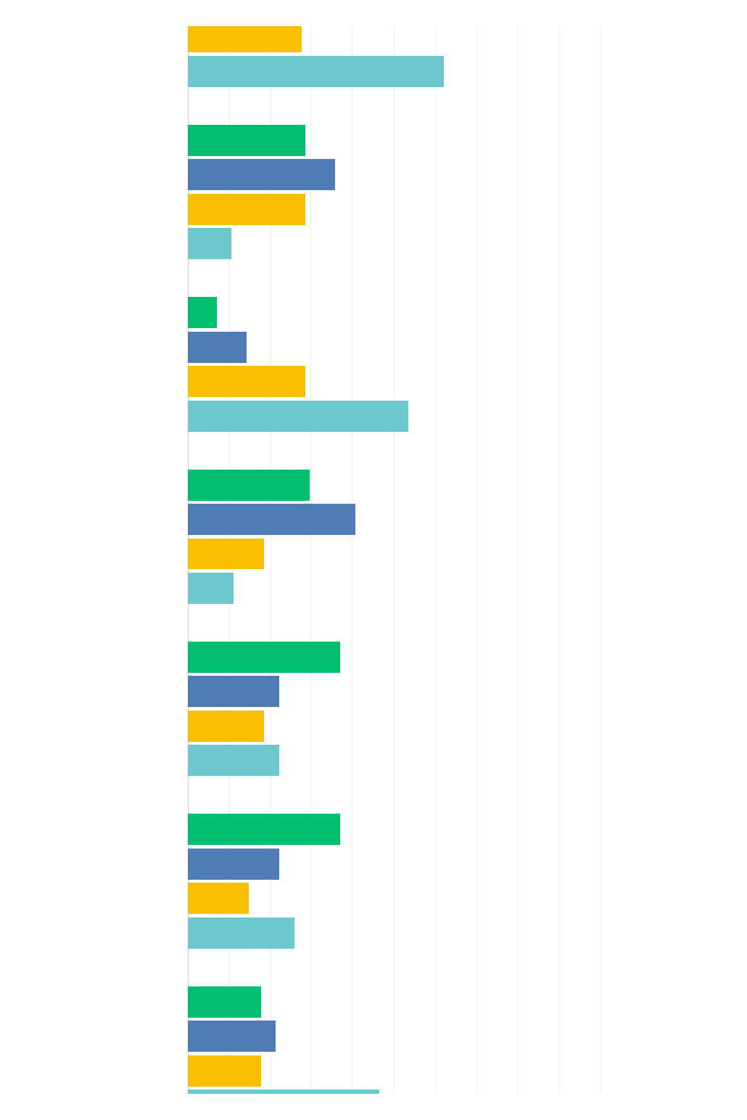

MEDIUM PRIORITY
TOTAL
RESPONDENTS
HIGH
PRIORITY
LOWEST PRIORITY
NOT
REQUIRED
Pneumatics/Hydraulics | 21.43%  6 | 21.43%  6 | 42.86%  12 | 14.29%  4 | 28
Electrical/Electronics | 10.34%  3 | 3.45%  1 | 48.28%  14 | 41.38%  12 | 29
Motor Control Systems | 15.38%  4 | 11.54%  3 | 38.46%  10 | 38.46%  10 | 26
Programmable Logic Controllers | 14.29%  4 | 10.71%  3 | 42.86%  12 | 35.71%  10 | 28
Optical Sensors and networks | 14.29%  4 | 32.14%  9 | 46.43%  13 | 7.14%  2 | 28
Problem Diagnosis and  troubleshooting | 3.45%  1 | 6.90%  2 | 27.59%  8 | 62.07%  18 | 29
Microsoft Applications | 28.57%  8 | 35.71%  10 | 28.57%  8 | 10.71%  3 | 28
Preventative Maintenance | 7.14%  2 | 14.29%  4 | 28.57%  8 | 53.57%  15 | 28
Hoisting and Forklift License | 29.63%  8 | 40.74%  11 | 18.52%  5 | 11.11%  3 | 27
Basic engine lathe and Bridgeport machining | 37.04%  10 | 22.22%  6 | 18.52%  5 | 22.22%  6 | 27
Advanced Machining (CNC) | 37.04%  10 | 22.22%  6 | 14.81%  4 | 25.93%  7 | 27
Blueprint Reading | 17.86%  5 | 21.43%  6 | 17.86%  5 | 46.43%  13 | 28

#
OTHER (PLEASE SPECIFY)
DATE

1 Licensed Electrician preferred or Apprentice's 9/11/2019 3:26 PM

Q11 - What schools or training organizations do you work with to train your
employees for Electro-Mechanical skills?
Answered: 30 Skipped: 9

Springfield Technical...
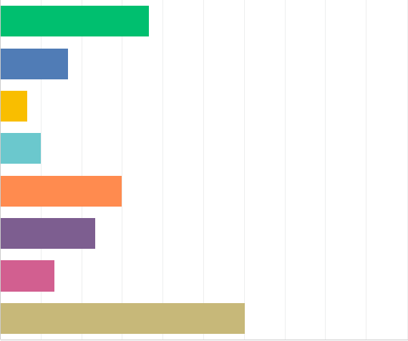
Asnuntuck Community...
Berkshire Community...
Greenfield Community...
Local or regional...
Third-Party/Private Training Vendor
Third-Party/Pri vate Training WTF
Internal training OJT
0% 10% 20% 30% 40% 50% 60% 70% 80% 90% 100%
ANSWER CHOICES | RESPONSES
Springfield Technical Community College | 36.67% | 11
Asnuntuck Community College | 16.67% | 5
Berkshire Community College | 6.67% | 2
Greenfield Community College | 10.00% | 3
Local or regional Vocational Technical High School | 30.00% | 9
Third-Party/Private Training Provider (vendor) | 23.33% | 7
Third-Party/Private Training Provider (Workforce Training Fund Trainer) | 13.33% | 4
Internal training program or On-the-Job Training | 60.00% | 18
Total Respondents: 30

Q12 - Please tell us anything else you would want us to know about your
company’s Electro-Mechanical skills needs
Answered: 7 Skipped: 32
# | RESPONSES | DATE

1 Have need for training etching process, relieving, shearing all positions we need to train right 9/11/2019 4:47 PM
person for
2 We have been searching for an Electrician or an Apprentice and have been unsuccessful for more 9/11/2019 3:26 PM
than a year. This is an ongoing search with limited to no results.
3 Apprentice programs in partnership with local high school has been beneficial in meeting our 8/28/2019 6:55 PM
Electro-mechanical needs.
4 Candidate needs to demonstrate initiative, positive attitude and the ability to work well with others 6/17/2019 3:13 PM
5 12 hour shift 6pm-6am; primarily servicing CNC machines 6/14/2019 1:30 PM
6 CNC operators for all three shifts is our biggest needs. 6/12/2019 3:27 PM
7 In a small company it is a huge expense to underwrite an internal training program, we have and 6/12/2019 2:16 PM
we continue to but it reduces efficiency, reduces our revenue stream.

