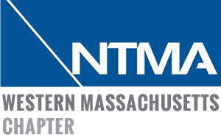
MANUFACTURING FORUM AGENDA
2/14/20

Registration and Networking 7:30 am – 8:00 am
Free Continental breakfast provided

Welcome by Kristin Carlson, President Peerless Precision

Opening/Welcoming Remarks 8:00 am – 8:05 am
Robert LePage, Assistant Secretary, MA department of Higher Education

Presentation of Regional Blueprint for Manufacturing 8:05 am – 8:15 am
David Cruise, President & CEO Masshire Hampden County Workforce Board (MHHCWB)

Mass Tech Collaborative Presentation – M2I2 Opportunities 8:15 am – 8:35 am
Ira Moskowitz, Director, Advanced Manufacturing Programs, Mass Tech Collaborative

Small Business Administration – Federal Contracting Opportunities 8:35 am – 8:45 am
Oreste Varela, Branch Manager, U.S. Small Business Administration

Electromechanical Staffing Needs and Workforce Development 8:45 am – 8:55 am
Research)
Larry Martin, Director of Business Services and Market Research, MHHCWB

Apprenticeships 9:00 am – 9:20 am
Melissa Scibelli, Director of Workforce Development Programs, MHHCWB
Daniel McDonough, Vice President of Human Resources, Smith & Wesson

Open Roundtable Discussion on Staffing Skills and Competencies 9:20 am – 10:00 am
For Existing and Near Future Workforce
Moderator: Jen Brown Vice President, Business Development, United Personnel
Subject Experts:
Workforce Development: Larry Martin
Economic Development: Rick Sullivan
Legislators TBD
Employer: Rick Cookish

